- The input file received from the client contains multiple rows of identical data for a single defendant. Utilizing the "FORM" column, we filter the data into a single row for each defendant and then write it to a dynamically created Excel file.
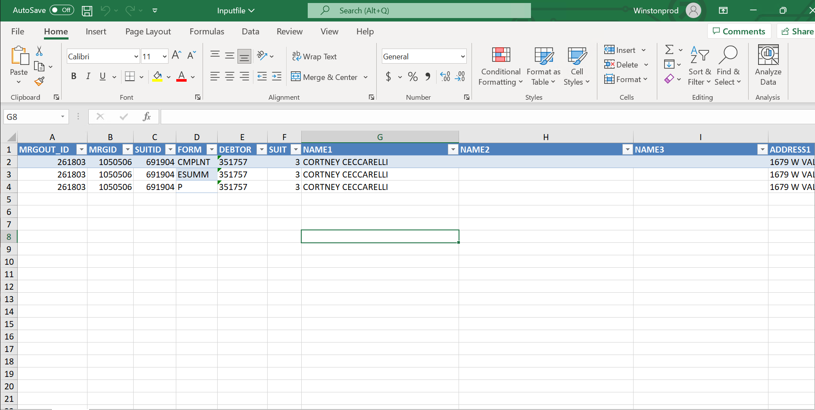

- The bot will iterate through the dynamically created Excel file, extracting the mandatory column details into different variables and performing data manipulation if necessary.
"SUITID","FORM","DEBTOR","SUIT","NAME1","NAME2","NAME3","PHRASE","CASENO","FILEYEAR","PLNT1","PRIMADD1","PRIMCITY","PRIMSTATE","PRIMZIP","SPADD1","SPCITY","SPSTATE","SPZIP","CBSATTORNEY","ATTCODE"
Then dynamic excel contains 4 more additional columns to like with the existing column from the input file like File identifier, Submission Number, Submission Date, Payment Confirmation Number, Total Fees, Transaction Details.

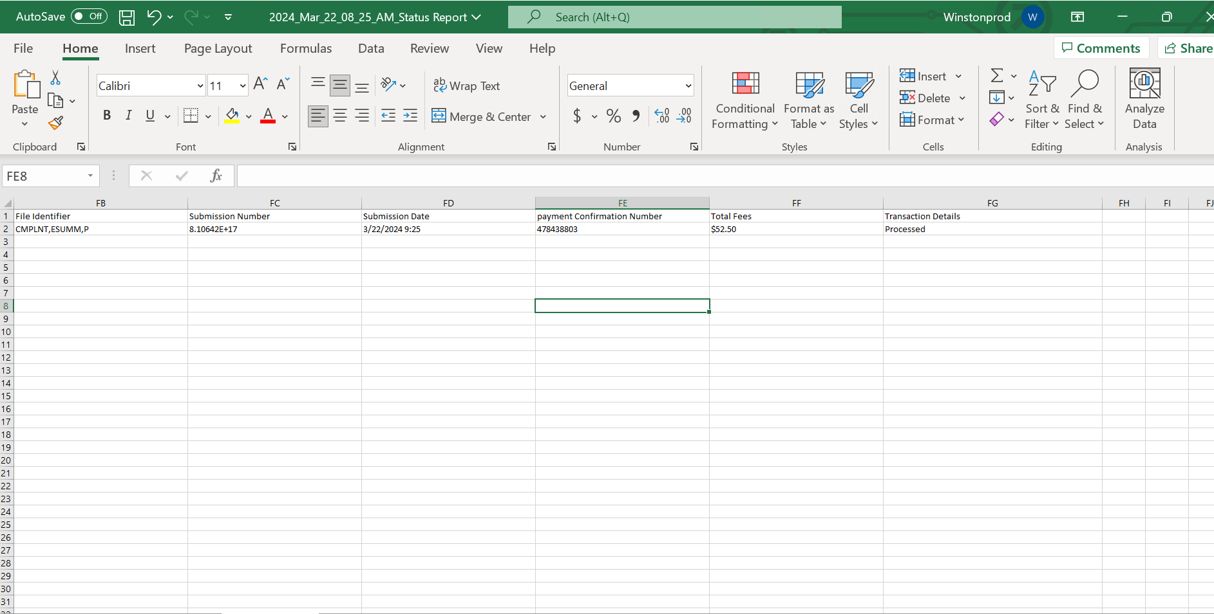
B.1) We utilize the value in the "Phrase" column to in the dynamic Excel file, where we identify the court name from the "Court" column and the court ID from the "ID" column in another sheet of same excel.

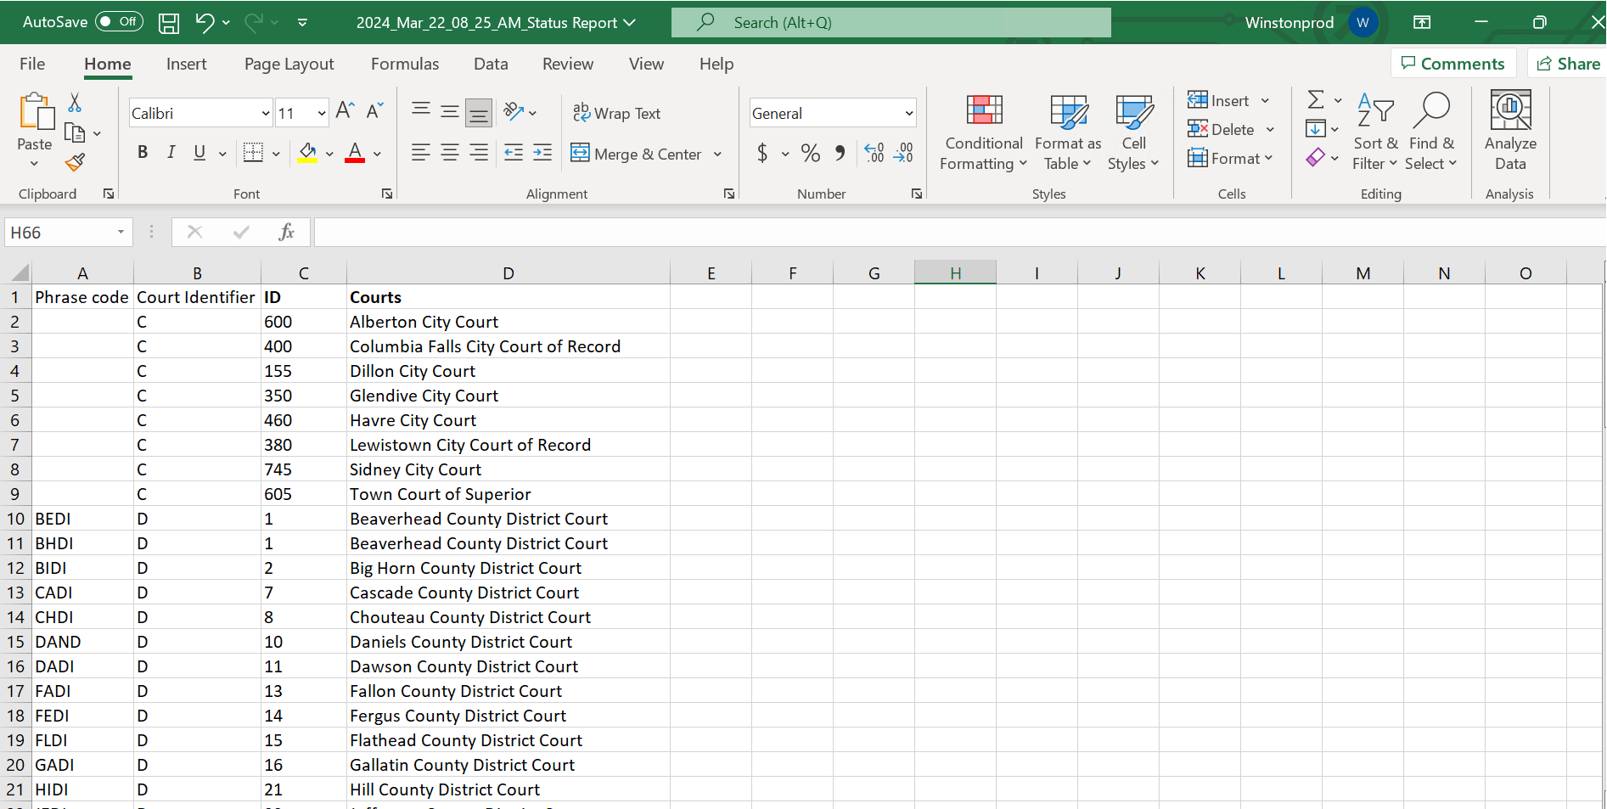

B.2) We utilize the value in the "PRIMSTATE & SPSATE" column to in the dynamic Excel file, where we identify the Defendan1 state and the Defendan2 from the " States " column in another sheet of same excel.

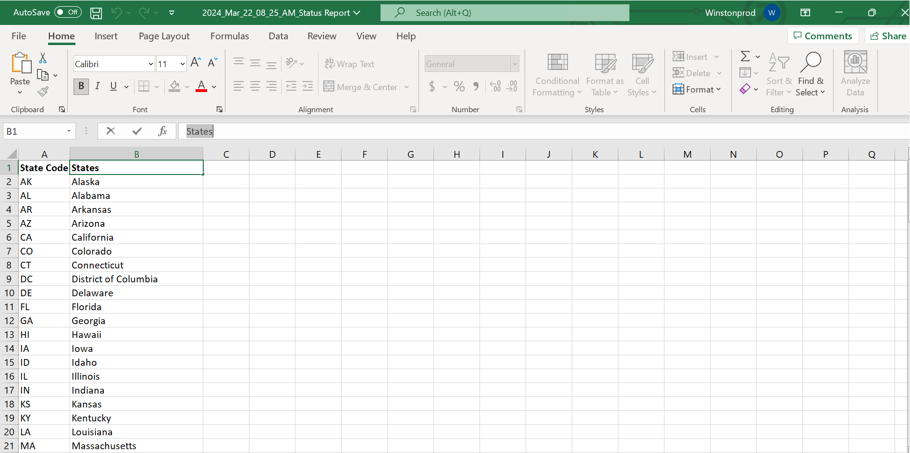

- Login to the Montana E-filing portal using the credentials saved in the config file.

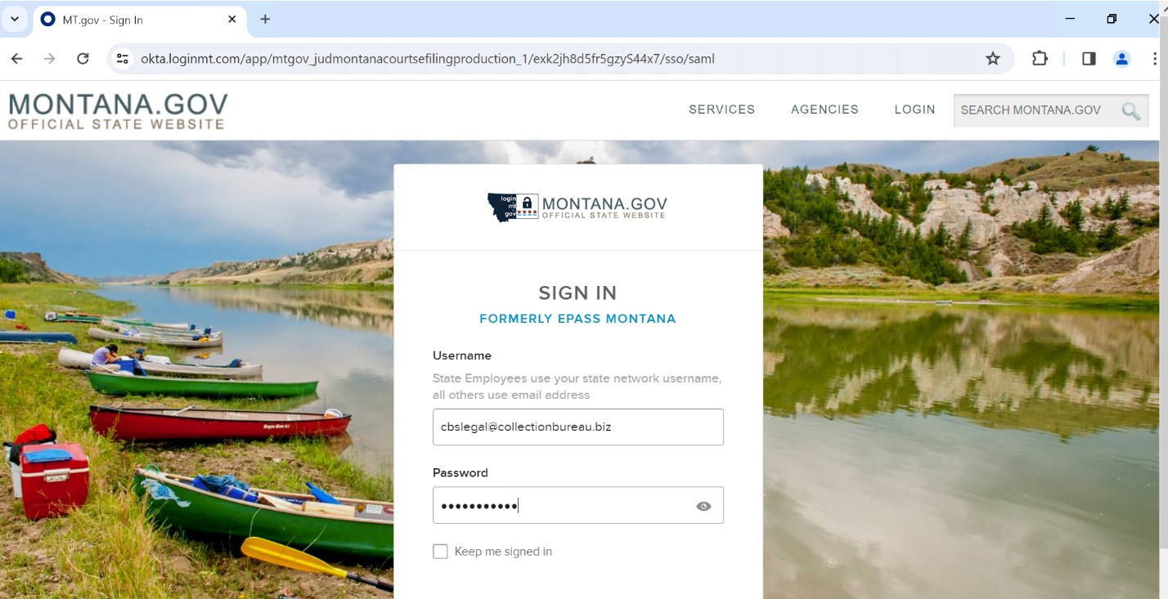
- By clicking Sign this will navigate to the Home page of Montana E-filing website while clicking Create Filing again navigate the bot to main page where we select the court and type of case.
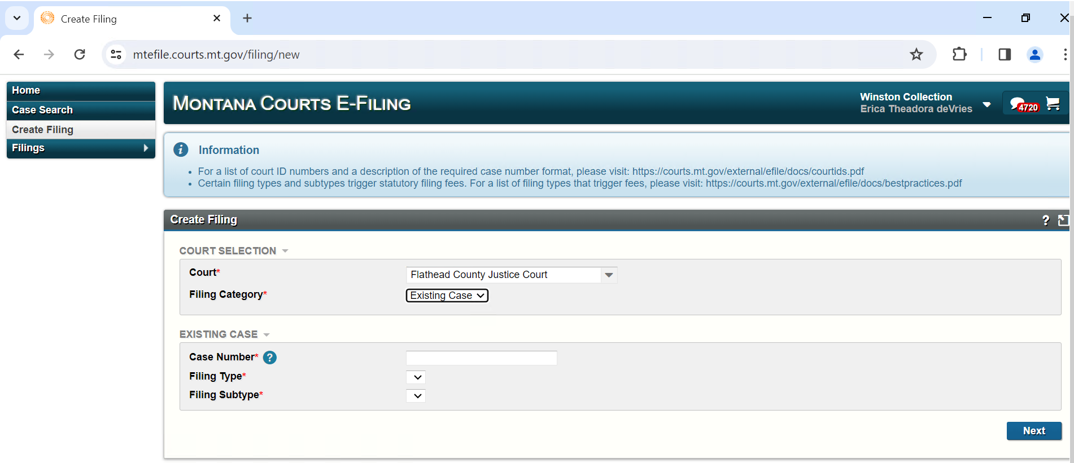
Court : Extracted from Dynamic file for the current defendant
Filing Type : Existing Case
Case Number: Extracted from Dynamic file for the current defendant
Filing Type : Motion
Filing Subtype: Motion of default judgement
Then Click Next.

- While clicking next this will navigate to Filing information page, Checks the check box of plaintiff with collection Bureau (Select State of Montana, If plaintiff with collection Bureau is not available) and clicks next.
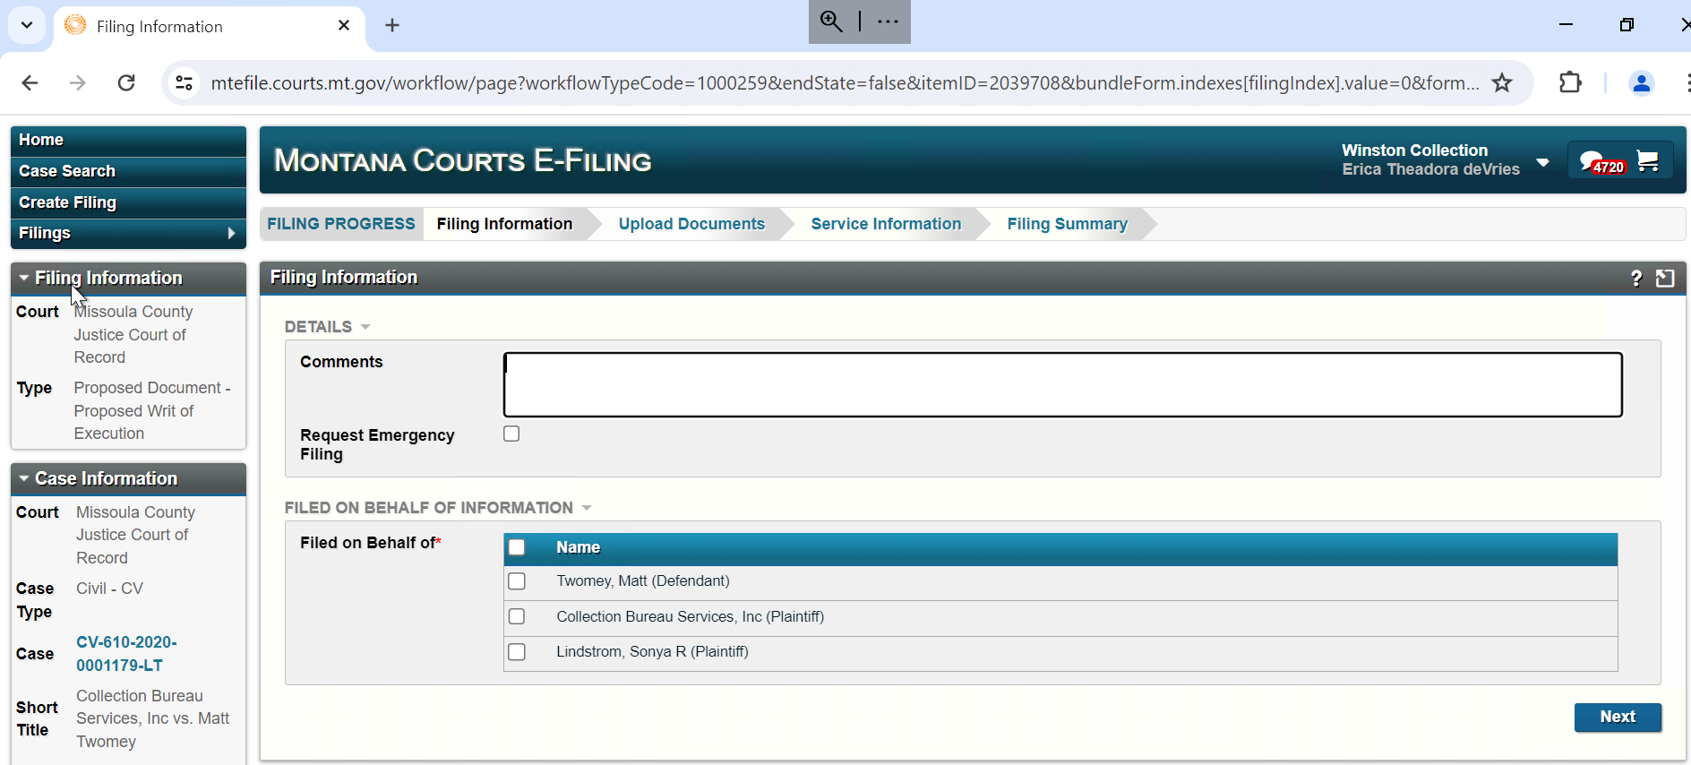

- While clicking next will navigate to Upload Documents page, Identify the document relevant to JDD using the naming convection and add document by clicking Add Another Lead Document
E.g.: File Name: 373167002m, 373167002j: mandatory document
373167002afa, 373167002aff, 373167002afc, 373167002ros: Optional documents
a) Here first 6 digit is value extracted from DEBTOR column; next 3 digit is the value extracted from SUIT column.
b) While uploading first document click on Exclude from eService’s check box.
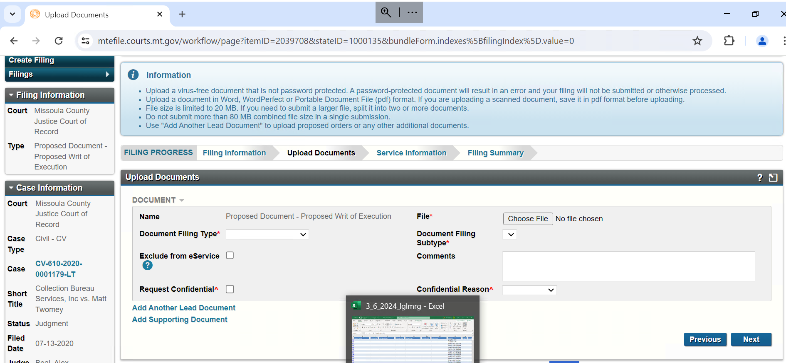
For upload If 2 documents are (Eg: 373167002m, 373167002j)
Document Filing Type : Motion
Document Filing Subtype: Motion of default judgement

Document Filing Type : Proposed Document
Document Filing Subtype: Proposed Default judgement
For uploading optional documents
Document Filing Type : Notice
Document Filing Subtype: Notice

Then click Next.

- While clicking Next will navigate to Service Information page, where clicks Next.

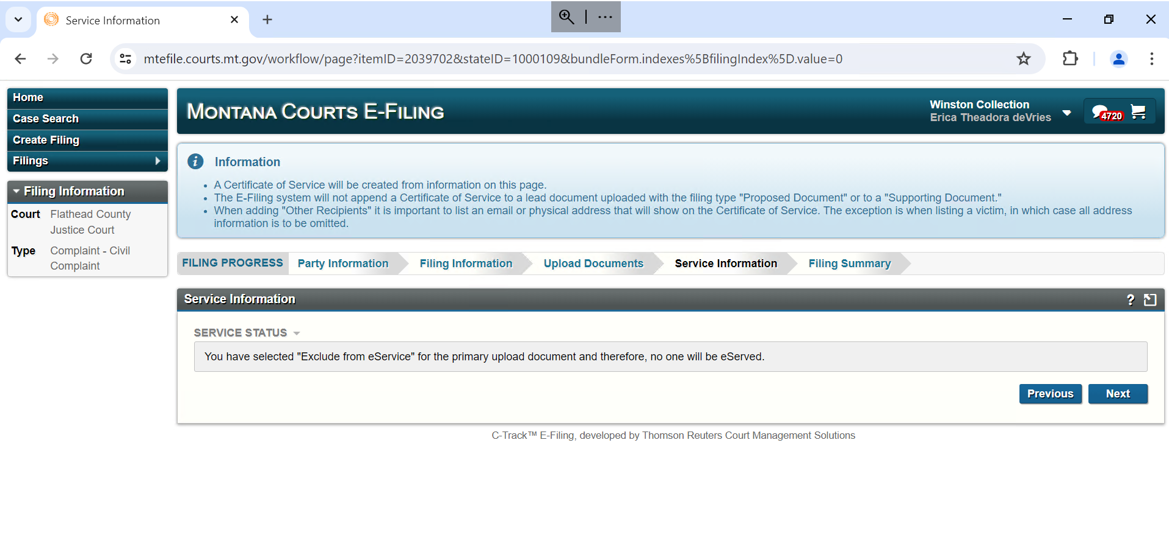
- While clicking next navigate to Filing Summary page, Click Add to Cart.
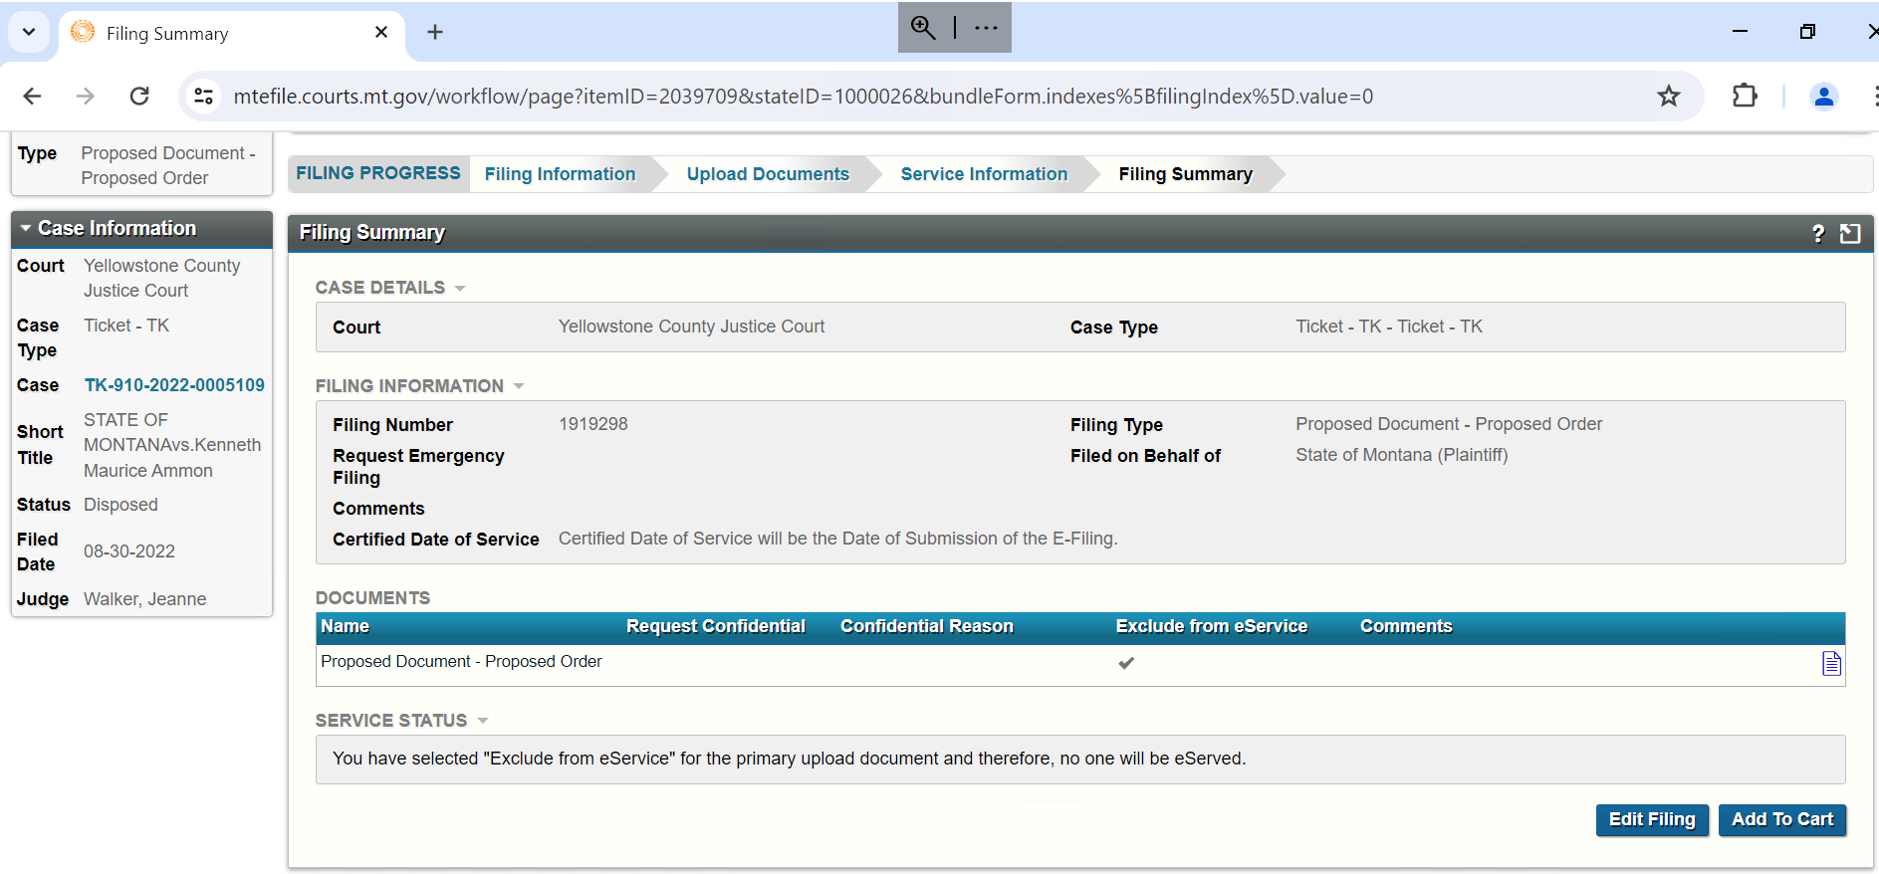

- While clicking next navigate to Submit page click Submit filing.
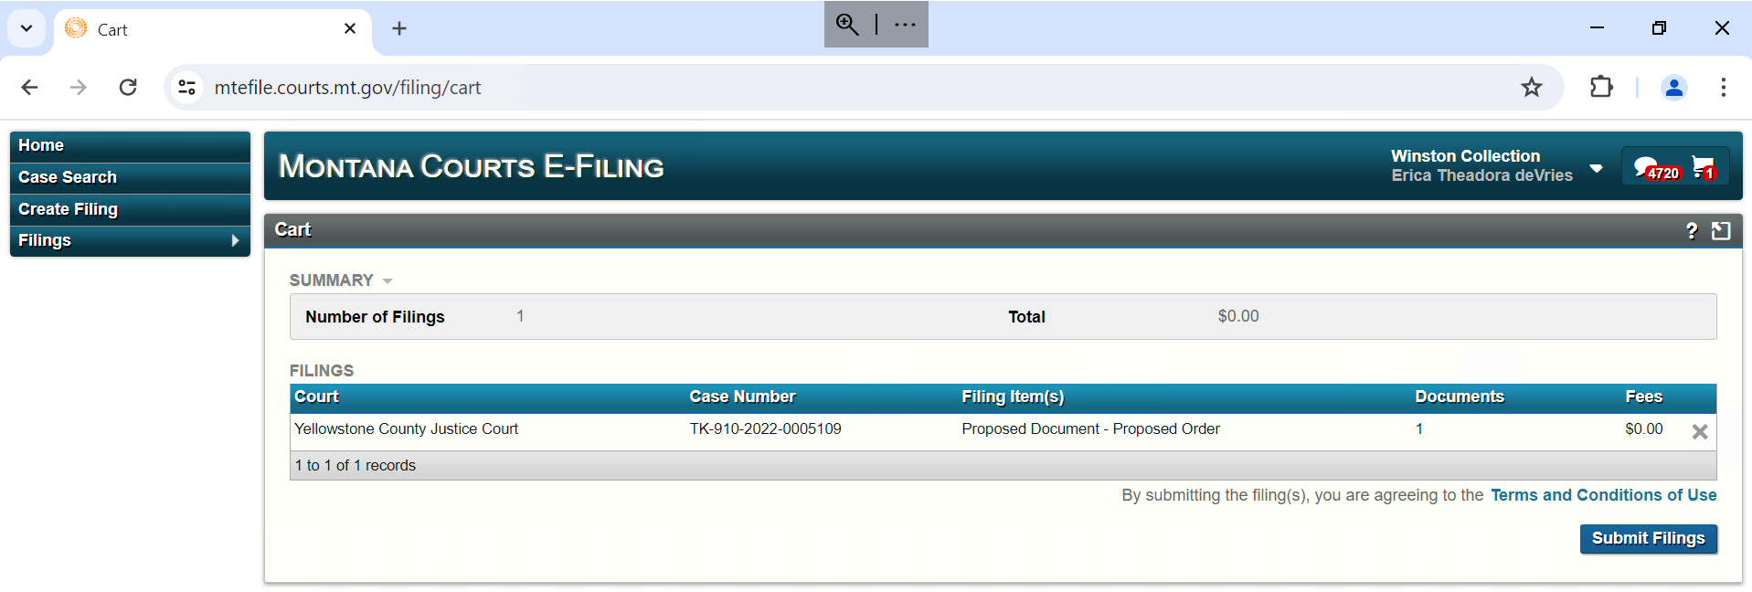

- While clicking submit filing process finished
- Send the log report to client through mail.

Business Rule Exceptions
- Debtor value is empty in input file
- Suit Number is empty in input file
- Form is empty in input file
- Phrase code is empty in input file
- Case number is empty in input file
- Court details not matching in Court master file
- Mandatory Columns missing in input file
- Mandatory document is not available input folder

